**Challenge 5**

[www.pythonchallenge.com/pc/def/peak.html](http://www.pythonchallenge.com/pc/def/peak.html)

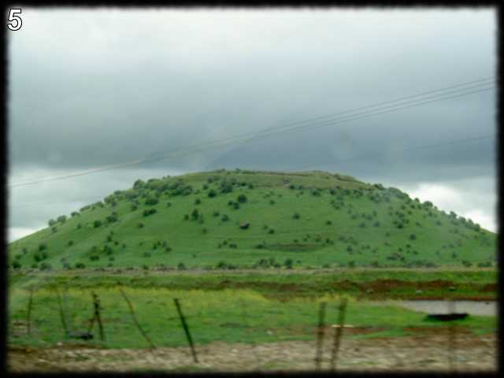  
***pronounce it***

*(I thought this challenge was significantly harder than the previous ones. I had to cheat a couple of times.)*

The page title is ‘peak hell’. I tried saying it fast and came up with ‘piquel’ which I thought might be a word in another language? Googling, I did get ‘pickling’ – so, of course, ‘pickle’ is what I want.

This turns out to be a python thing (and now that I look at it – the image looks like a pickle). From python doc:

*The*[*pickle*](https://docs.python.org/3/library/pickle.html#module-pickle)*module implements binary protocols for serializing and de-serializing a Python object structure.*“Pickling”*is the process whereby a Python object hierarchy is converted into a byte stream, and*“unpickling”*is the inverse operation, whereby a byte stream (from a*[*binary file*](https://docs.python.org/3/glossary.html#term-binary-file)*or*[*bytes-like object*](https://docs.python.org/3/glossary.html#term-bytes-like-object)*) is converted back into an object hierarchy. Pickling (and unpickling) is alternatively known as “serialization”, “marshalling,”*[*1*](https://docs.python.org/3/library/pickle.html#id7)*or “flattening”; however, to avoid confusion, the terms used here are “pickling” and “unpickling”.*

What? I decided to look into that stuff later. In the meantime, I tried …pickle.html and go this message: yes! Pickle!

There’s also a line with ‘banner.p’ in the source.

. . . banner.p is a page with a long list of stuff like this:

(lp0

(lp1

(S' '

p2

I95

tp3 . . .

There are several nice little pickle examples out there:

***playing with pickle:***

***dogs_dict1 = { 'Ozzy': 3, 'Filou': 8, 'Luna': 5, 'Skippy': 10,***

***'Barco': 12, 'Balou': 9, 'Laika': 16 }  
 outfile = open('dogs','wb')  
 pickle.dump(dogs_dict1,outfile)  
 outfile.close()  
  
 infile = open('dogs','rb')  
 dogs_dict2 = pickle.load(infile)  
 infile.close()***

So, the plan is to create a file (bytes – notice files are ‘rb’, ‘wb’) from the weird stuff. Then let pickle.dump transform it into some kind of table. The result is this:

[(' ', 95)]

[(' ', 14), ('#', 5), (' ', 70), ('#', 5), (' ', 1)]

[(' ', 15), ('#', 4), (' ', 71), ('#', 4), (' ', 1)]

...

There was a little ‘aha’ moment. The file is named banner.p. In the olden days, banners where things like

---XXX--- . . .

--XX-XX—-

-XX---XX-

-XX---XX-

--XX-XX—-

---XXX---

So, the pickle output looks like a list for each row: 95 blanks, 14 blanks + 5 ‘#’, etc.

Printing it the banner leads to the clue word ‘channel’. Putting that in the url takes us to the next challenge.